Motorcycle Crashes in East Africa
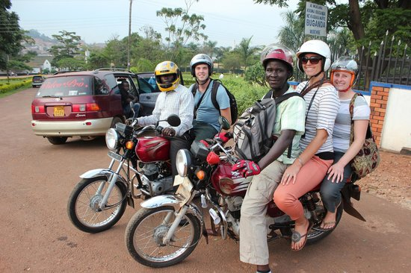
In the United States, it’s typical noticing motorcycles riding around while driving, possible carrying another passenger, on the road. These are private-owned vehicles, so these people aren’t strangers to one another and the driver follows the traffic safety laws alongside other vehicles. This is quite different in East Africa, where there are narrow roads and heavy traffic that bring vehicles, buses, and cabs to a complete halt for hours. It’s common to notice motorcyclist zoom through the traffic to get their passengers to their ultimate destination, often carrying two people or even an entire family on the same bike. These are known as “boda boda,” or motorcycle taxis, and they are a prominent mode of public transportation in countries like Kenya, Tanzania, and Uganda. An illustration of this is shown in Figure 1.

Figure 1: Illustration of Boda Boda in Uganda
Motor Vehicle crashes are a major cause of morbidity and mortality globally. According to the World Health Organization, the “rates of road traffic death are highest in Africa (26.6 per 100,000 people),” and a majority of these deaths are among pedestrian and motorcyclist accidents (Global status report…, 2018). This rate is significantly higher than the national average of 18 deaths per 100,000 people (Matheka, Omar, Kipsaina, & Witte, 2015). Since motorcycles have very limited safety features to protect drivers, motorcycle taxi drivers are a vulnerable group for road related injuries. It was discovered that males are the risk factor because motorcycle taxi drivers are dominated by males, often poorly trained and unlicensed, and they’re more likely to take risks (Matheka, Omar, Kipsaina, & Witte, 2015). Table 1 shows causes of road related injuries that was discovered; negligence of the drivers was the highest reported causes of crashes (33.0%), followed by slippery road conditions caused by rain or sand (21.0%) (Nguyen, Vissoci, Joelson, Pesambili, Haglund, Gerardo, Staton, 2018).
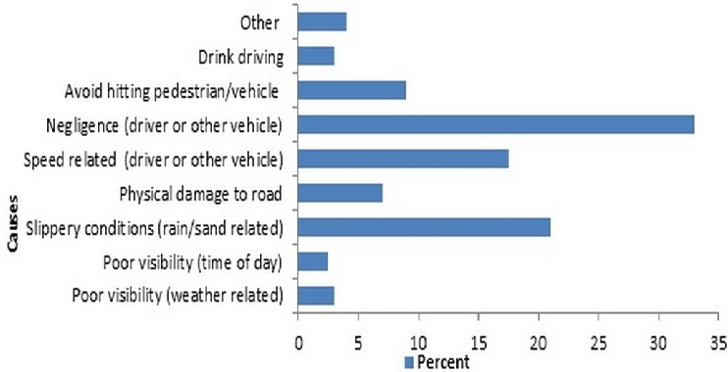
Table 1: Reported causes of crashes in Kenya
Financial burdens were also associated with road traffic injuries on countries and can cost “LMICs (low- and middle-income countries) over $100 billion annually in both direct medical costs and lost wages” (Nguyen, Vissoci, Joelson, Pesambili, Haglund, Gerardo, Staton, 2018). and “RTIs (road traffic injuries) are the second leading cause of death among men between 15 and 49 years old...” (Nguyen, Vissoci, Joelson, Pesambili, Haglund, Gerardo, Staton, 2018). This extensive data just reflects that the motorcycle taxi program has a major injury problem in East Africa.

